7 August, 2026
Today’s topic –
User wise validation rules
- Customer care: Bunty Babli
- If we write validation rule for customer care and that will be applicable for bunty and Babli, so we can write for – user level and profile level.
Steps –
- Click on setup

- Click on Applicant
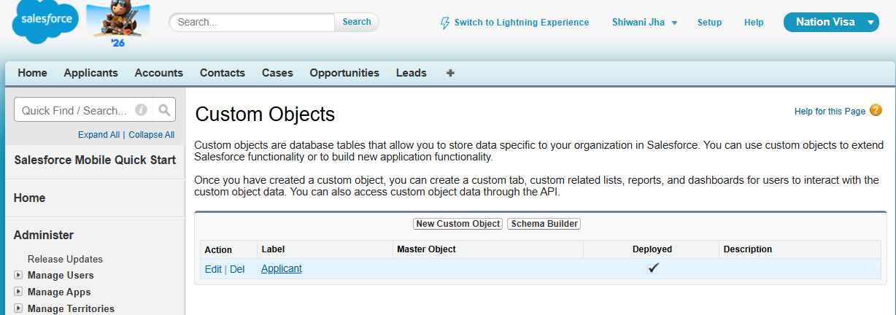
- Prevent rule for only specific
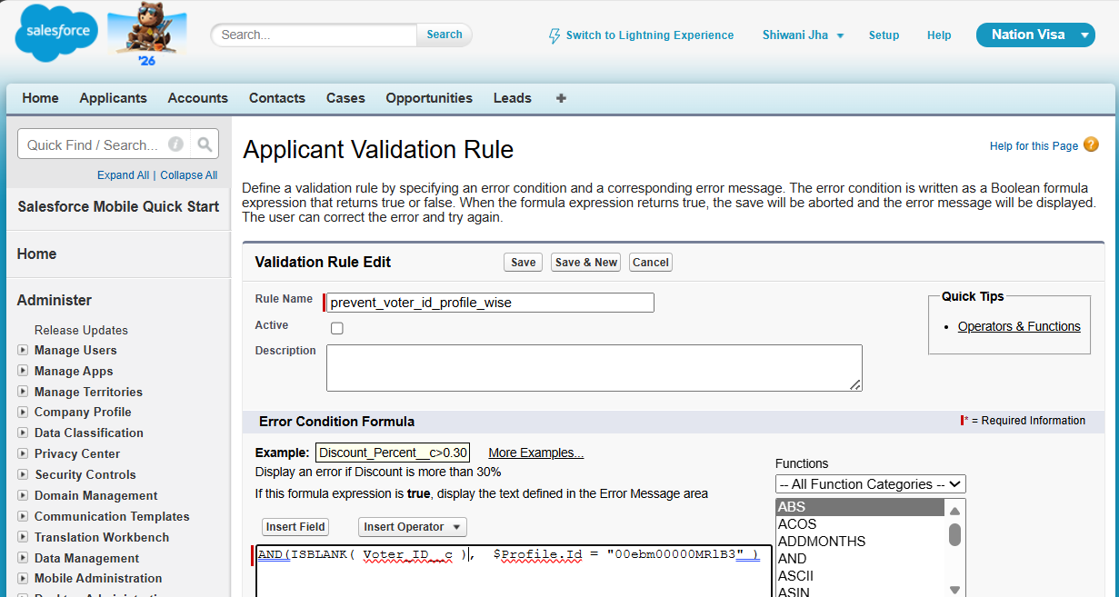
New way to write-
In this we will use Profile name.
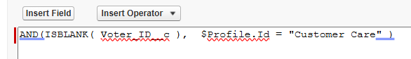
Note-
Class name: pascal
Func, variable in: camel case

User story 1:
Aadhar card mandatory for one profile, but not all.
Step 1
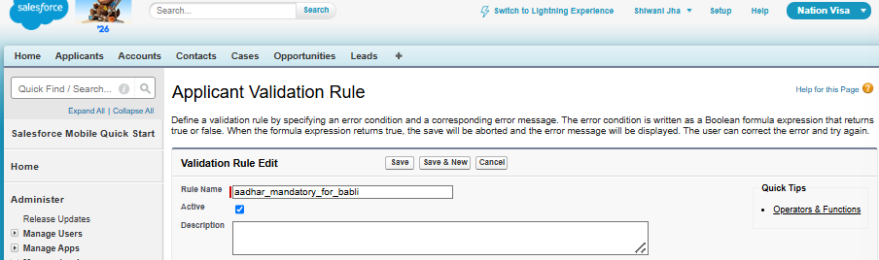
Step 2
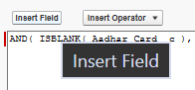
Step 3
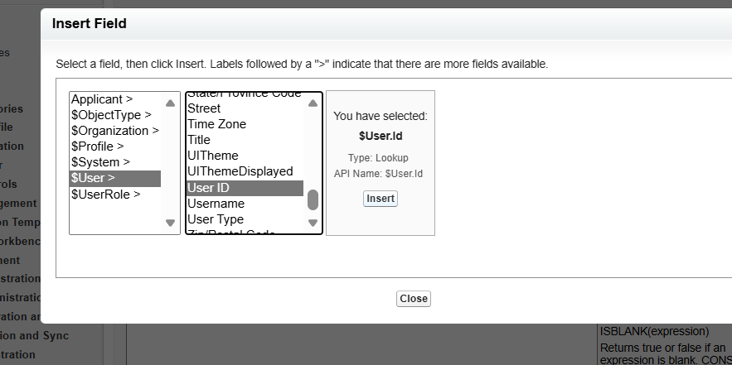
Step 4

Step 5
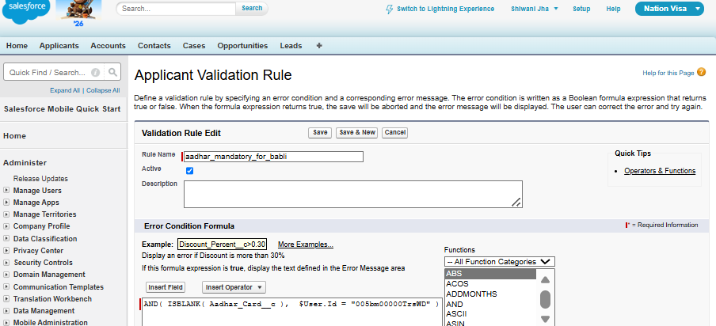
Bunty user id –
https://orgfarm-b79ae2a0d4-dev-ed.develop.my.salesforce.com/005bm00000Trrj7?noredirect=1&isUserEntityOverride=1
Bunty id - 005bm00000Trrj7
Babli id - 005bm00000TrsWD
Babli user id –
https://orgfarm-b79ae2a0d4-dev-ed.develop.my.salesforce.com/005bm00000TrsWD?noredirect=1&isUserEntityOverride=1

Page layout
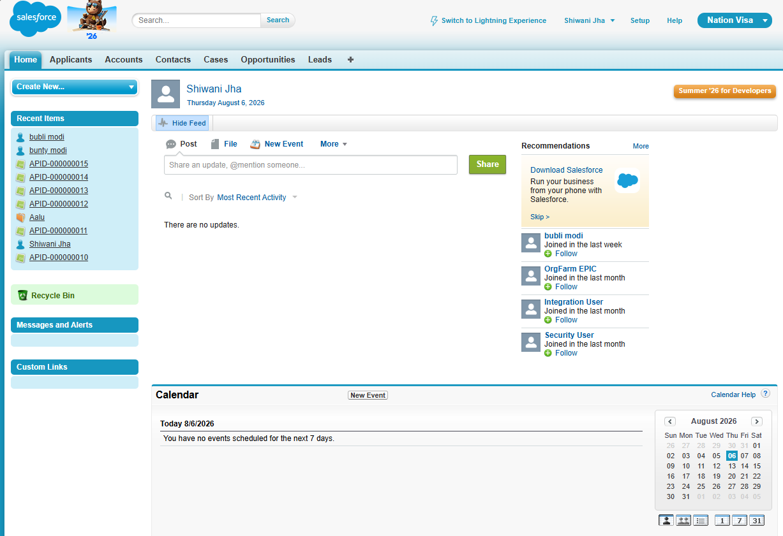
Detailed page
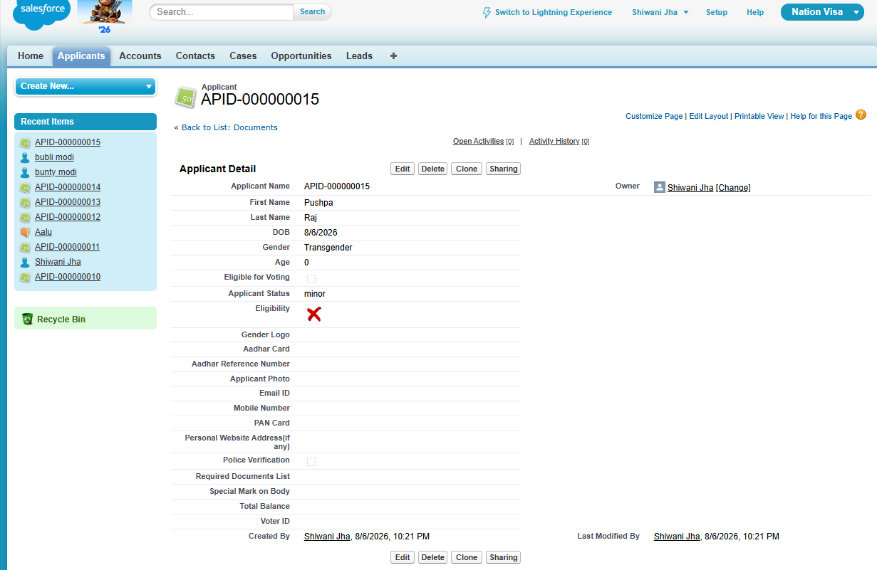
Related list
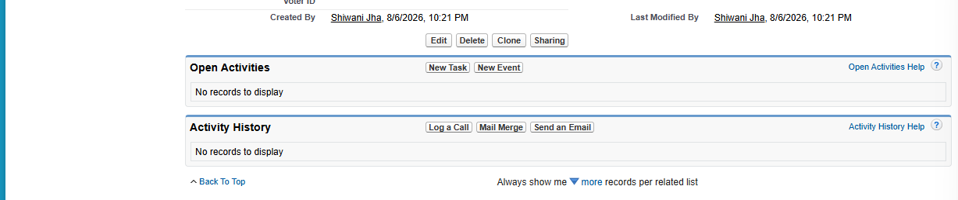

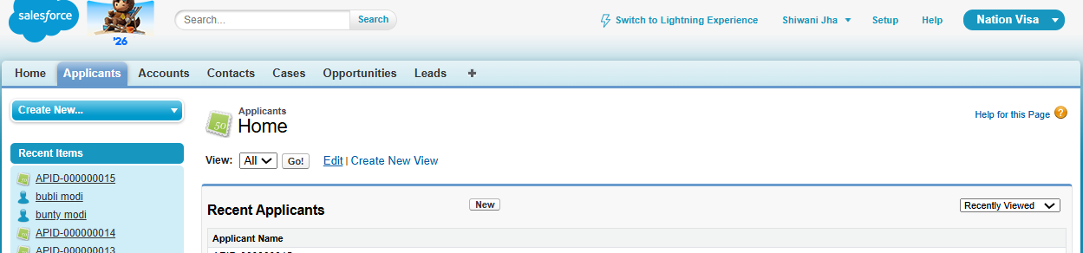
Steps to add more in list of applicants.
- Click on edit 
- Add the fields which you want.
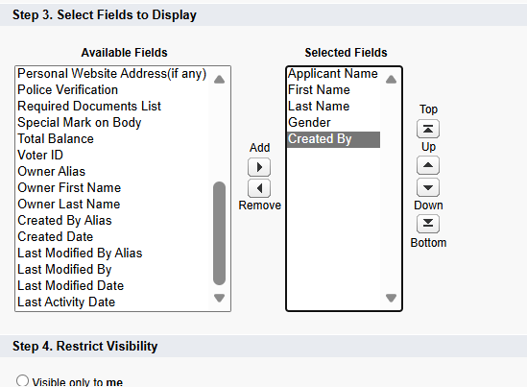
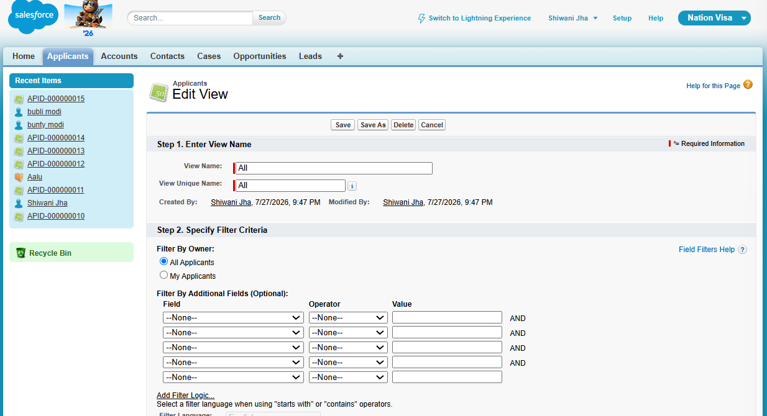
Result- List view of all data
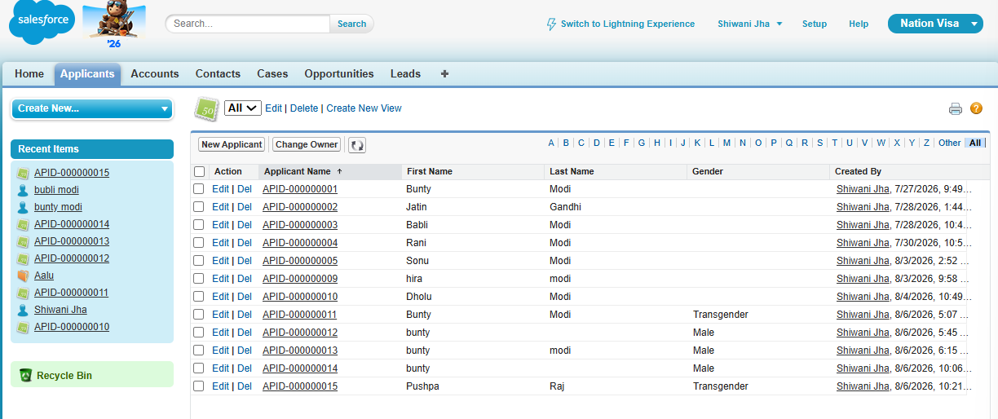

Page layout:
- It is used to decorate the detail page.
- It is used to make a field mandatory
- It is used to make a field visible/ hide.
- We can assign different page layout to different profiles.
Mandatory karne ke ways – meta data level, use required option.
Steps to - decorate the detail page.
Step- 1

Step 2
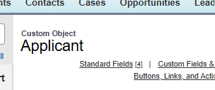
Step 3
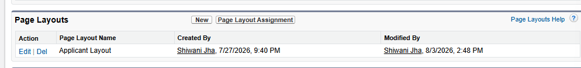

Step 4
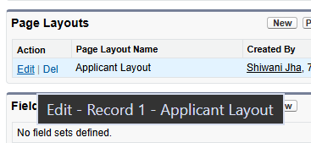

Step 5
Drag the section from top to the middle to make new section.
Repeat until you get the number of sections you want.
You can see the new section.
Now drag the fields that you want in that particular section.
Then quick save it and still you will be on same page.
But to save and finally leave that page , click on “Save”.
It will get permanently save.
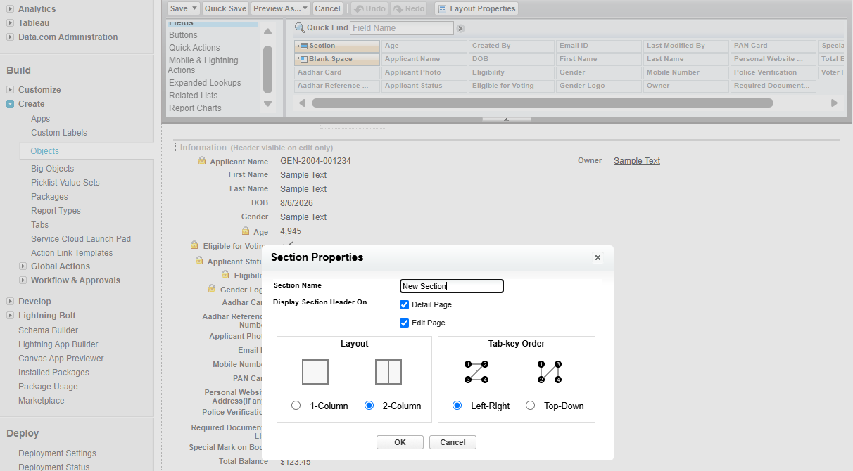
See new section-
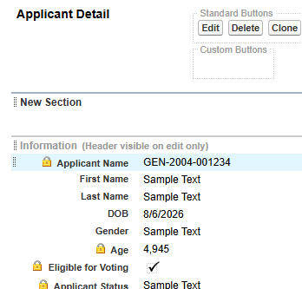
Add the fields which you want from dragging it.
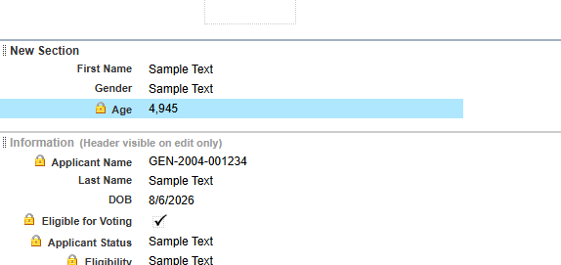
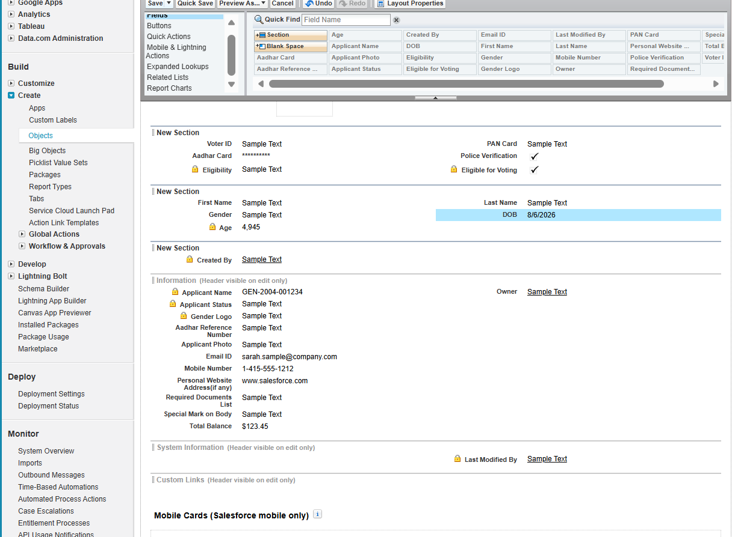
Result-
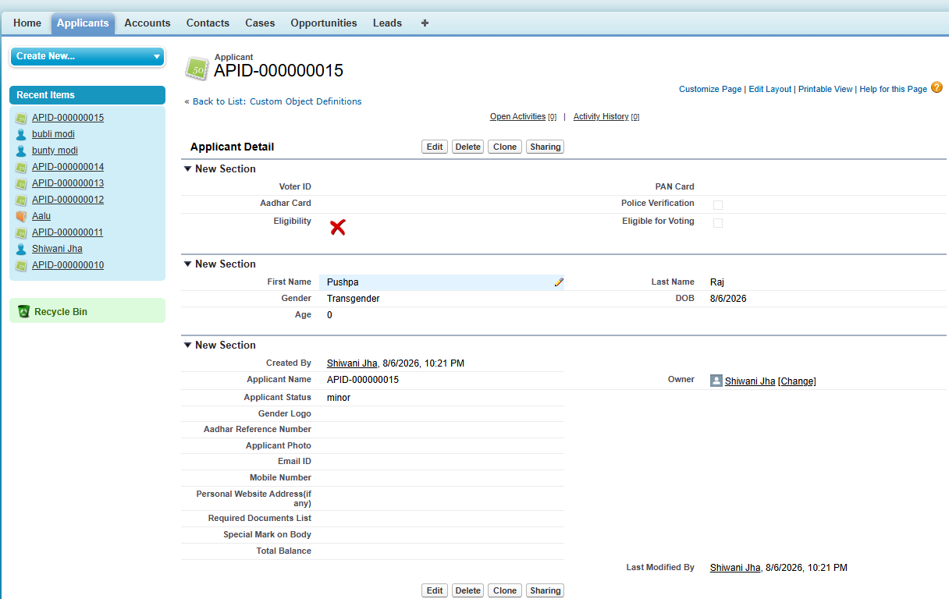
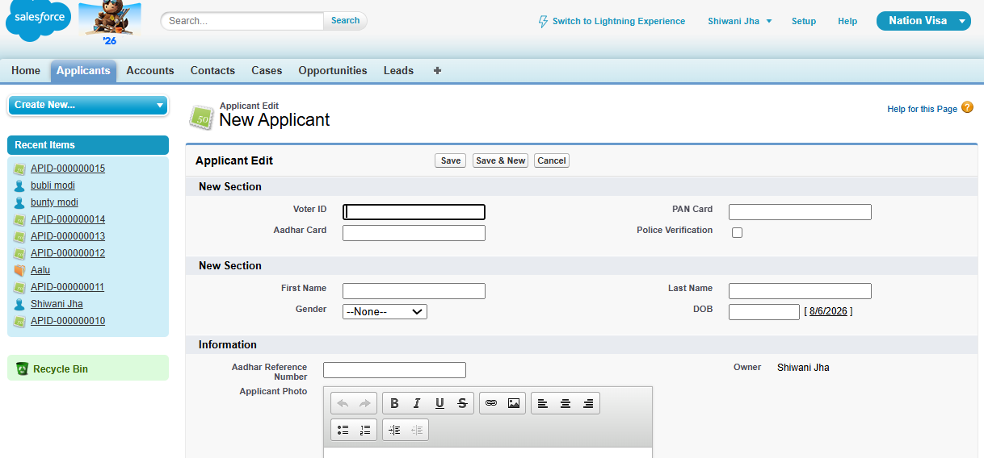

Steps to
- make a field mandatory and
- make a field visible/ hide.
Step 1: click on “” this symbol to change its mandatory function.
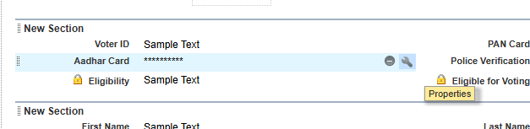
Step 2: Tick on “Required” and then it will become mandatory field.
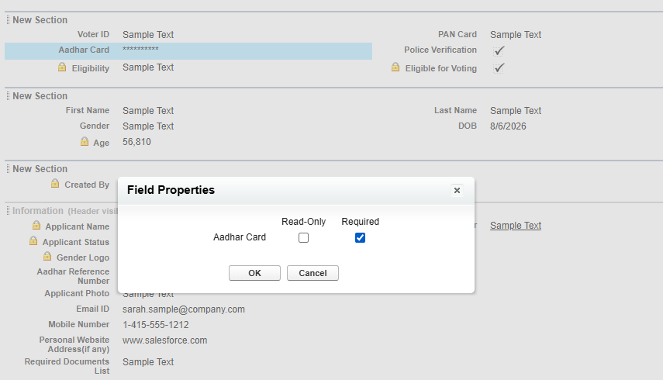
Result –
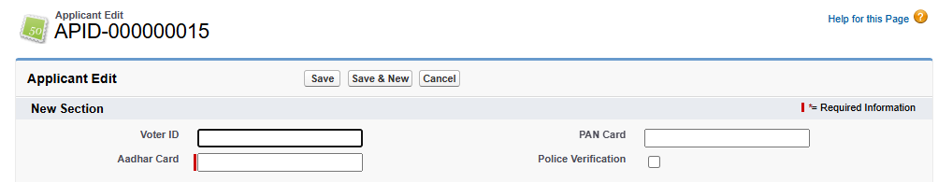
Total 3 ways:
- Meta data
- Validation Rule
- Page Layout
Layout and meta data have same error message, but “validation rule” can have different message different.

Hide by page layout
User story - Hide voter id
Step 1: Click on “” and then it will hide that particular field.
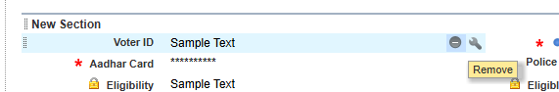
You can see that voter id field is hidden.
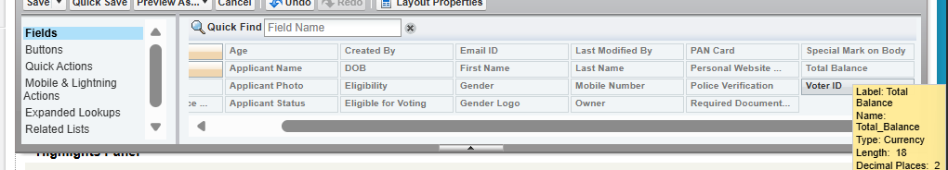
Result-
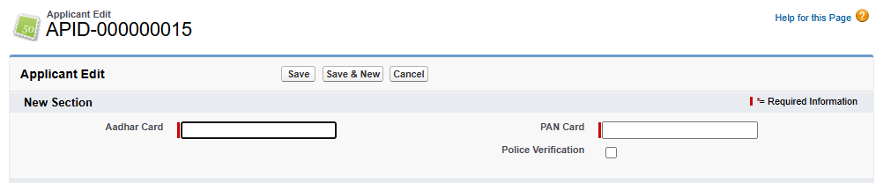

If we want different page layout for different users,
So we can make new layout, but will give only to “profile”.
To give to particular user, use validation rule.
We can assign different page layout to different profiles.
Bunty is user of profile: “customer care”
So will make layout from “admin“ for that profile “customer care”.
Step 1
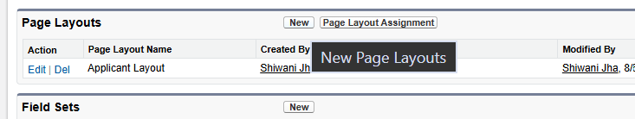
Step 2
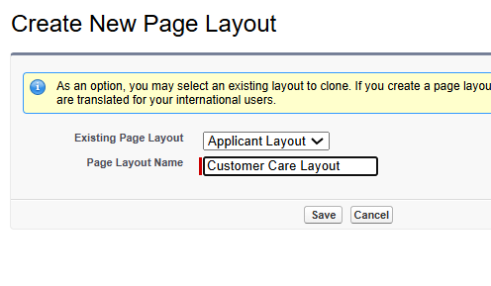
Step 3
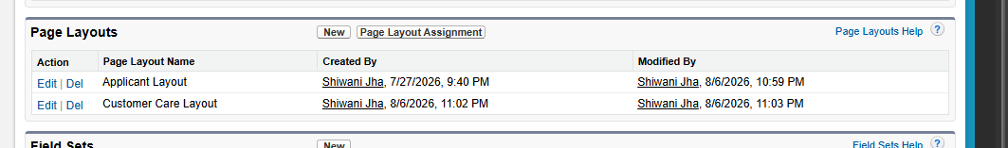
Step 4
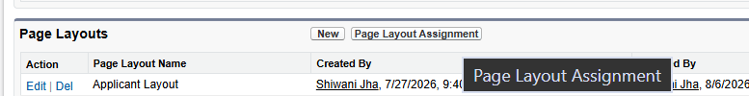
Step 5
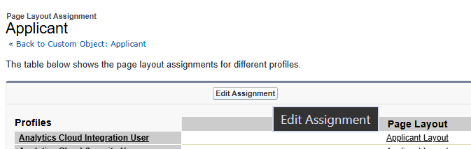
Step 6
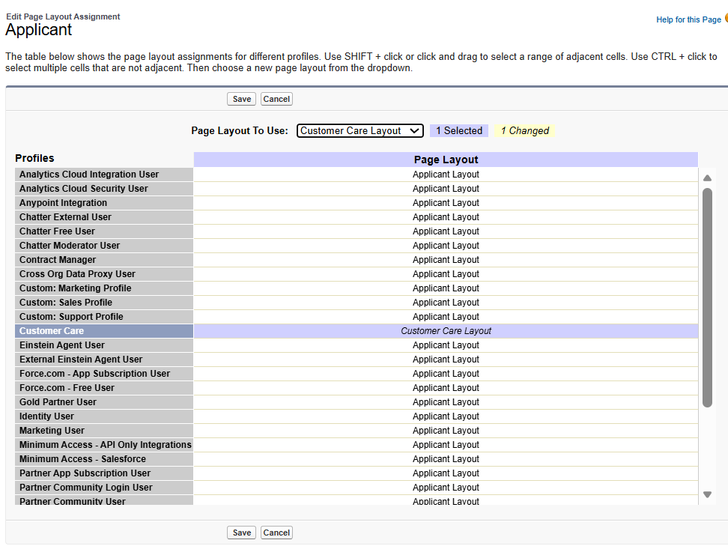Result check –
For “Admin” it shows Aadhar card and pan card as mandatory.
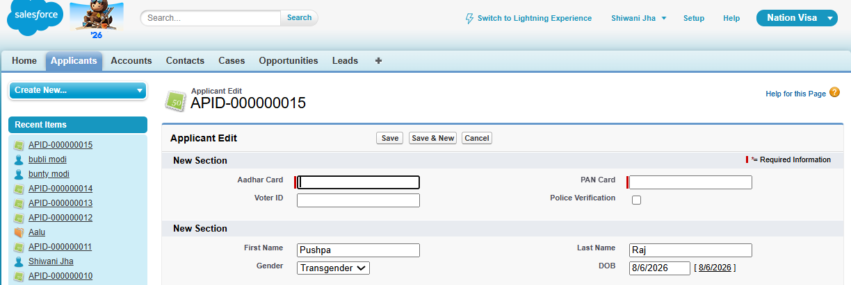
But for “Babli – who is from customer care profile” shows voter id card and pan card as mandatory.
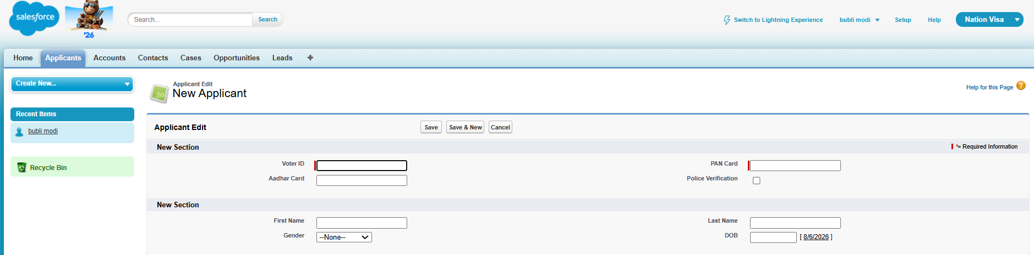
Difference between Page layout and validation rule-
- Error different
- User wise work from validation rule, profile wise from page layout
Steps to change security from admin to give profile “customer care” the access of the applicants and other things that are needed right now.
Step 1
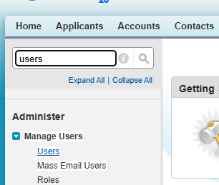
Step 2: Click on “Edit”
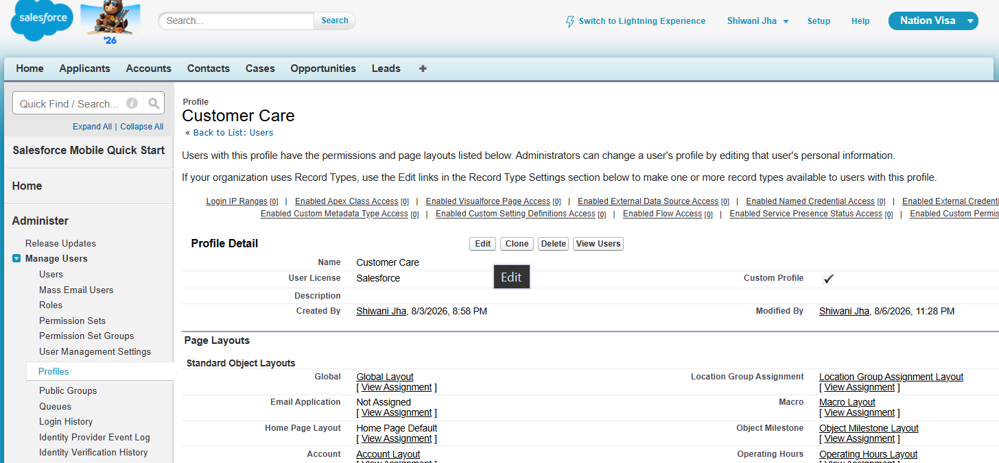
Step 3: Tick read, create and edit.
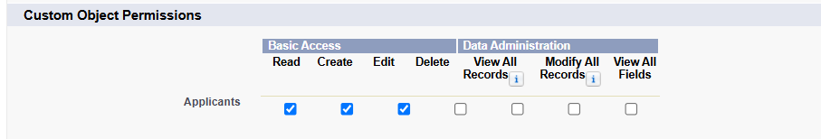
Step 4: Save it.
Step 5: Again on this page, scroll down and click on Applicant[view].
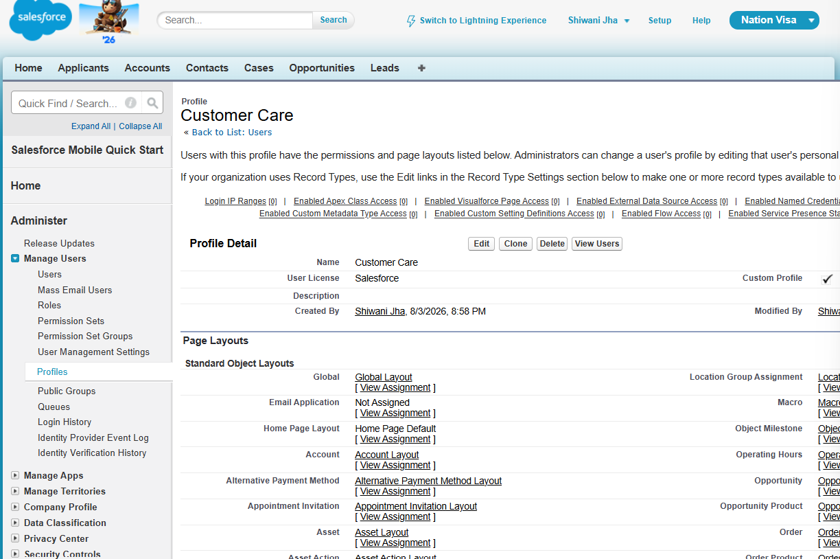

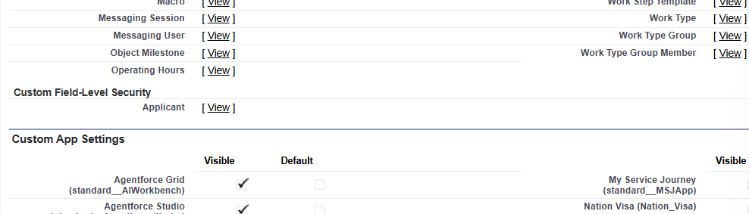

Step 6: click on this

Step 7: Click on “edit”
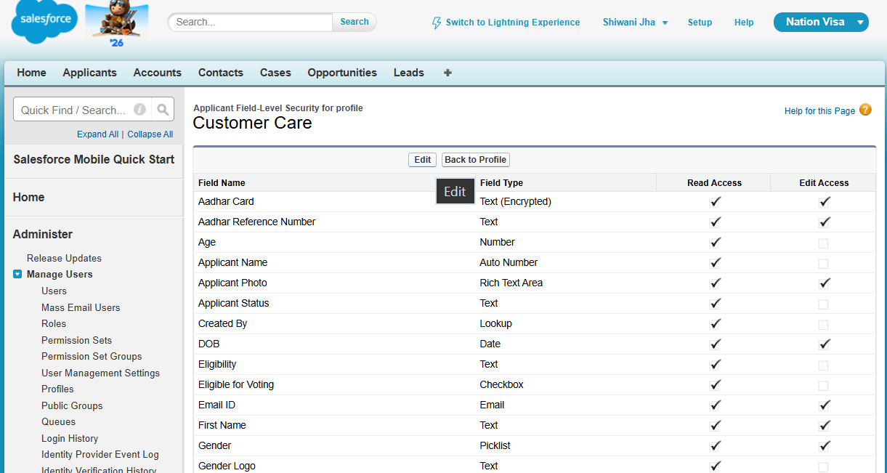
Step 8: Tick all the unchecked ones from “edit access” and save it.
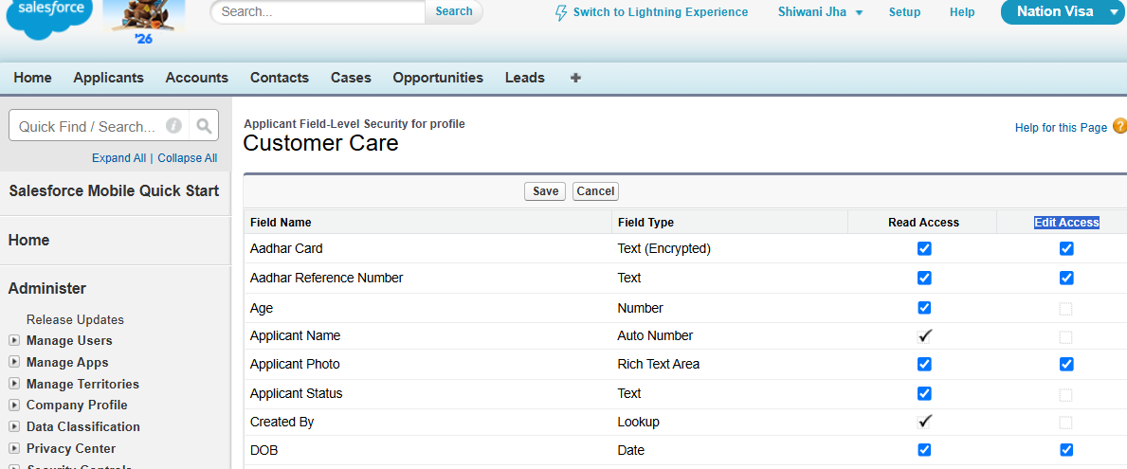
Now Check User ids like babli and bunty from profile customer care.
Result:
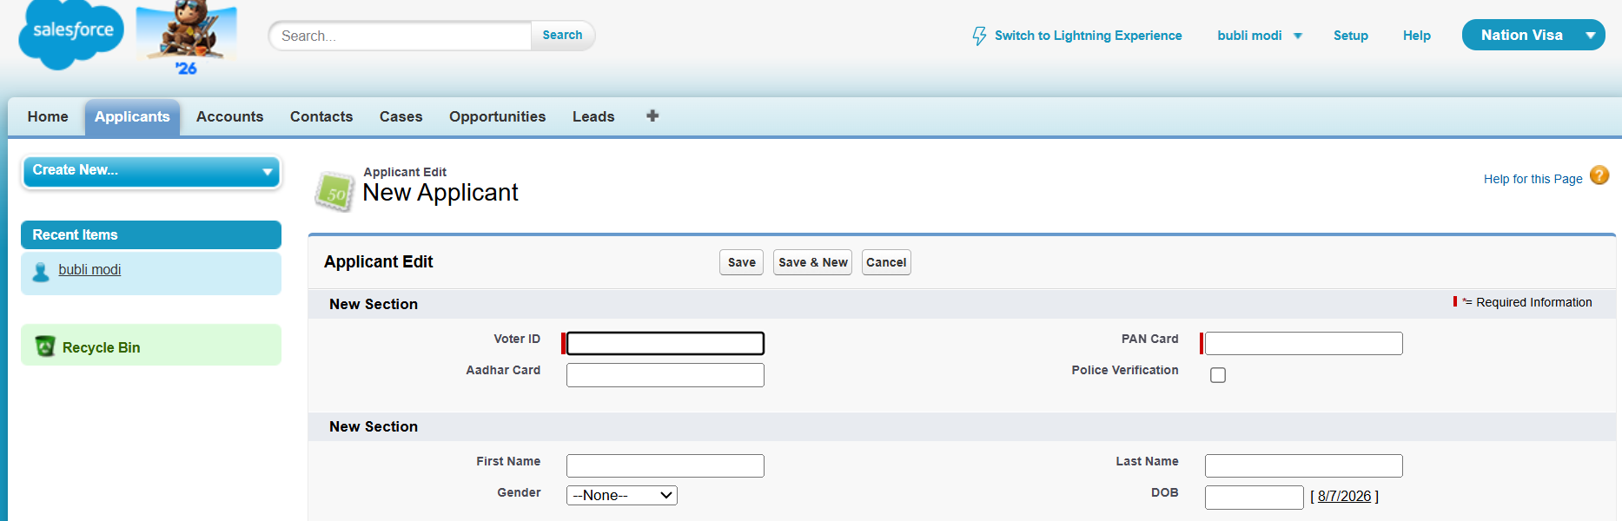

Relationships
Object “a” | object “b”
Bunty |
“applicant” | “address”

Banty ke 3 addresses- Bhopal, Indore, Nagpur, Delhi, Mumbai
Relationship – one to many, many to many
Field limit for one object in salesforce- 500
So, use relationship concept to make relationship so we can make more fields.
Types of relationship:
- Master detail
- Lookup relation
Master detail: if there are 2 objects – applicant(master) and address(detail) and then there is md relation.
- Master is mandatory while creating detail.
- If we delete master then detail gets deleted cascading
- If we try to make md relationship, then detail should not have record pehle se.
- Rollup summary fields.
- Example: doctor master, medicine details. Prescription mandatory.
Lookup Details:
- one parent, one child.
- Parent delete, no child delete.
- If child is already there, still no issue.
- Example, we have to buy balm, so we don’t need master doctor. Prescription not mandatory.

